Problem 1:

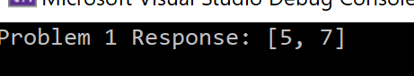

Problem 2:

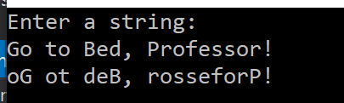

Problem 3:



Problem 4:



Problem 5:

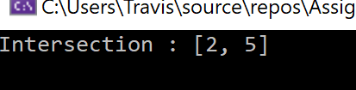

Problem 6:

